Home Learning Pack
Sometimes work set online can feel overwhelming for our children with SEND, no matter how brilliantly planned by our fantastic teachers.
Here is a selection of activity ideas for you and your child to do together should your child be finding some of the work set on Google Classroom challenging. You can replace some of the activities with some of these, photograph and hand in instead.
The pack is split into sensory/practical activities sorting/fine motor activities and Maths/English/PSHE based work. There are a range of fun activities in this booklet. Please turn towards the back of this booklet for more challenging activities.
I hope you find parts of this booklet useful to do at home.
With best wishes from,
Karen Ayres :)

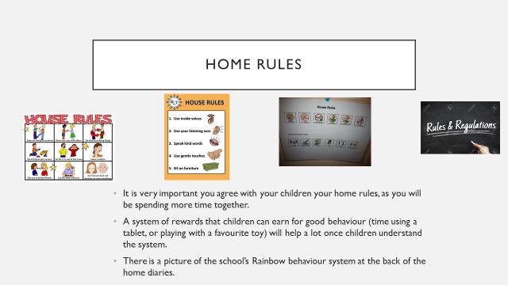

Visual Timetables
On the next page there is a morning learning timetable and an afternoon learning timetable examples for you to use at home to help you establish rules and routines. We would not expect you to use them both at the same time. Choose either a morning or an afternoon timetable to use at home. Anything you can do to support your child at home will be beneficial to their learning outcome.

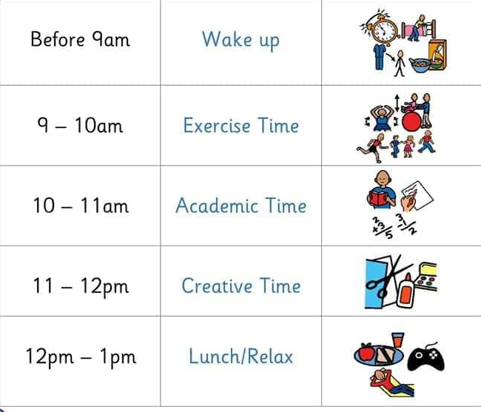
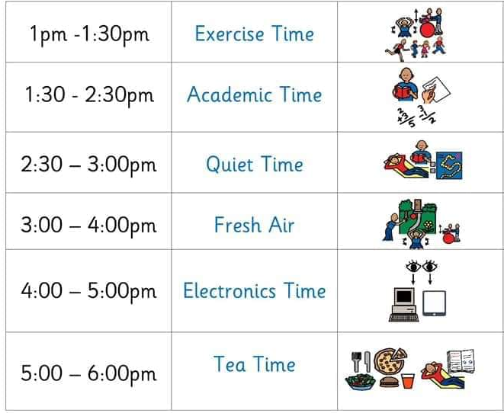

Life Skills
Baking and Cooking!
A wonderful way for you to spend time together with your child and great learning opportunities!
You could bake a cake, pancakes, make playdough or make tonight’s dinner together.
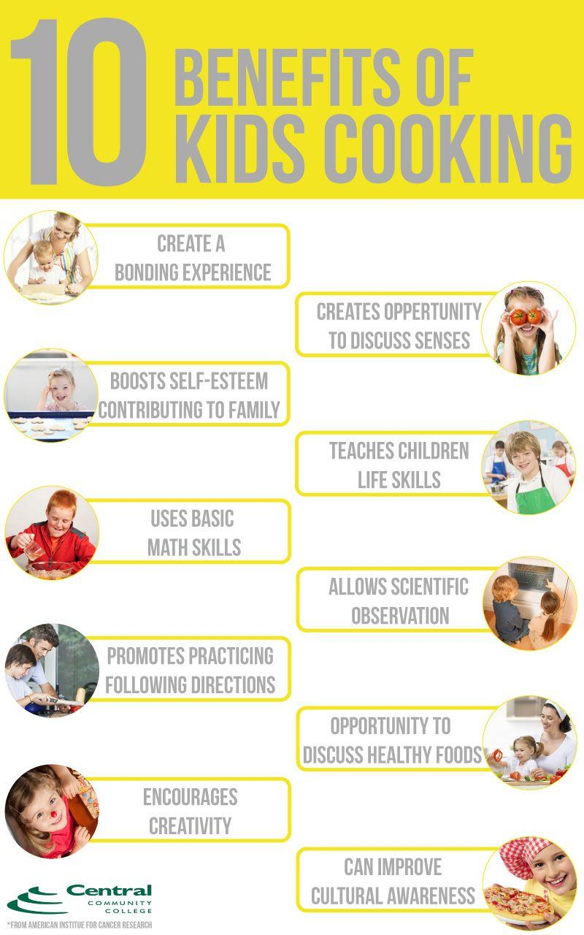
Some other life skills to learn during my time at home
Learning to get dressed by myself.

Learning to make my bed by myself.

Learning to go to the toilet by myself.

Learning to clear up by myself.

Sharing/taking turns with my brothers/sisters/
relatives

Challenge
You could write a recipe about something you have made/cooked at home.

Senses Activities
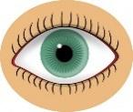
These will help to develop memory, listening and language skills.

Sight – Play a game of ‘I Spy’ (this one is also handy for practising letter sounds!)

Touch – Hide some toys in a box or under a blanket, then challenge your child to work out what they are using only their sense of touch. This is a great opportunity for them to practise describing how things feel.
To extend this you can also play Kim’s game. Place objects on a table then cover them with a blanket. Take one of the objects away and then remove the blanket. Can your child work out what object has been removed? Make this game more challenging by including more objects. This is a great game for memory skills and language.

Taste – Confuse the senses by adding some food colouring to drinks and see if your child can work out what they are (for example blue food colouring in milk, or red in some orange juice). For more daring eaters, they could try a blindfolded taste test of familiar foods!

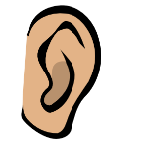
Hearing – Have a ‘listening minute’, where children spend a whole minute just listening to the world around them, then talk about all the sounds they could hear afterwards. Were the sounds loud or quiet? Nearby or far away? High or low?

Smell – Put some smelly foods into cups or beakers, and cover with kitchen roll or paper, with small holes poked in. Challenge your child to work out what’s inside using only their sense of smell (mints, coffee granules, orange segments, curry powder and baked beans all work quite well).
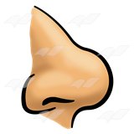

If you’d like to make some slime of your own at home, use the instructions below.

To make your slime you will need:
A cup of cornflour
UP TO one cup of water
A few drops f food colouring (optional)
How to make your slime:
Place your cornflour and a few drops of food colouring into a bowl.
Gradually add your water and start mixing until you have a slimy/solid consistency. Make sure you don’t add the water too fast.
Done! Now play with your slime!
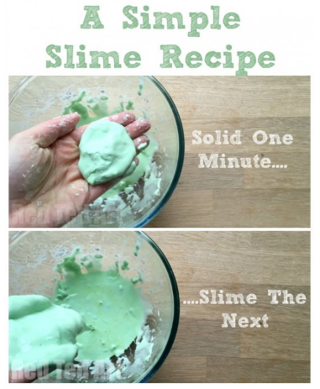

What’s going on?
The beautiful slime is known as a “Non-Newtonian fluid”. That just means it’s not really a liquid or a solid (it’s kind of both and kind of neither).

More Fun Please! - Experiment like a real scientist!
• Experiment with your slime. Try prodding it with your finger quickly and it will feel hard like a solid or if you pour it across your hands slowly it will feel like a liquid.
• Try making different coloured slimes.
• Try and make the ‘perfect slime’ with different amounts of water!

IMPORTANT! - When you are done with your slime, not for some time I’m sure! - Don’t pour it down the drain. The slime will separate back into cornflour and water and this can clog the pipes.

Challenge – You could write your own instructions on how you made slim!

Here are some practical ideas you can do at home with your child. Encourage their curiosity and independence.
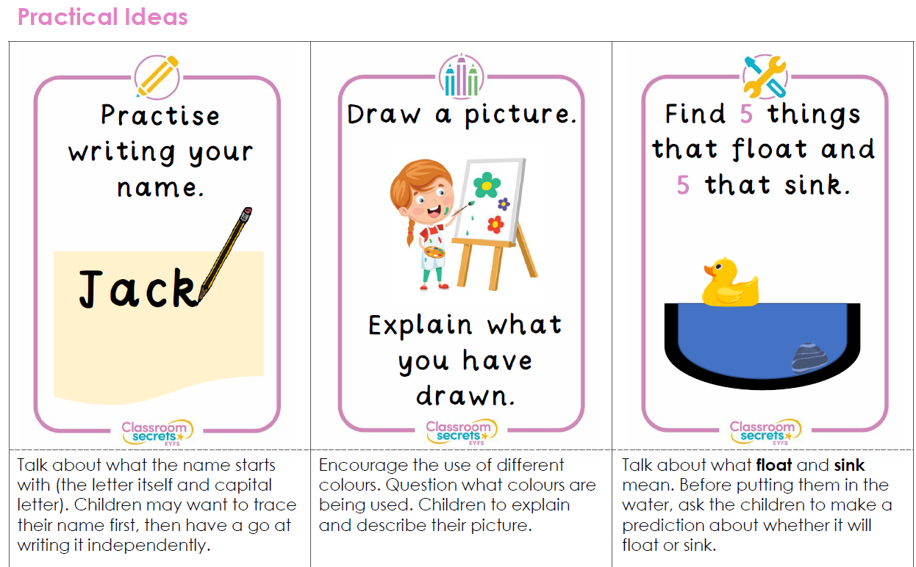
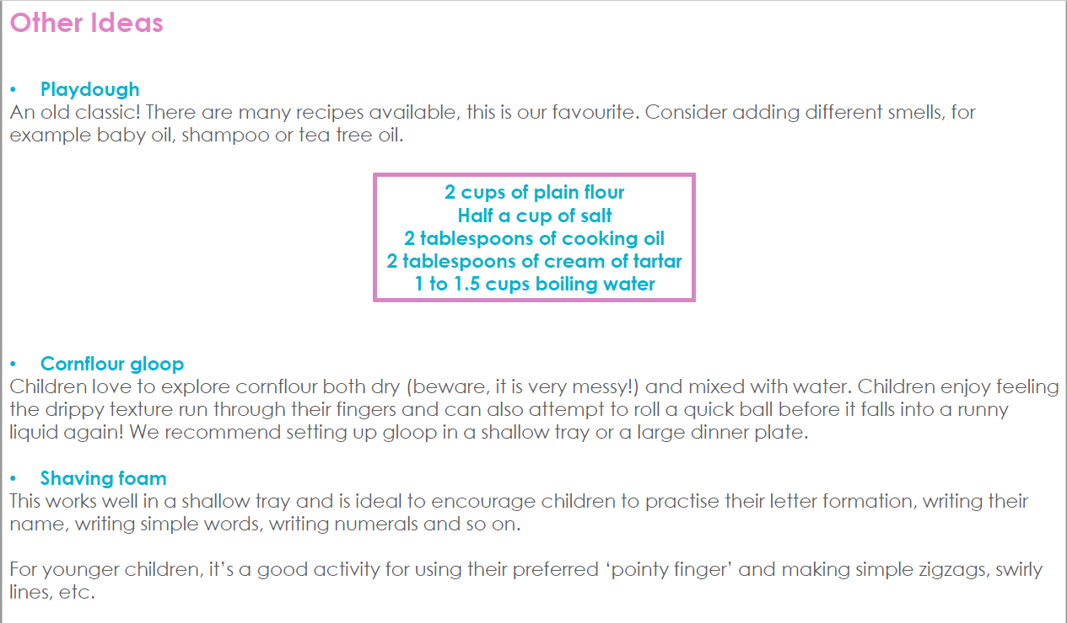
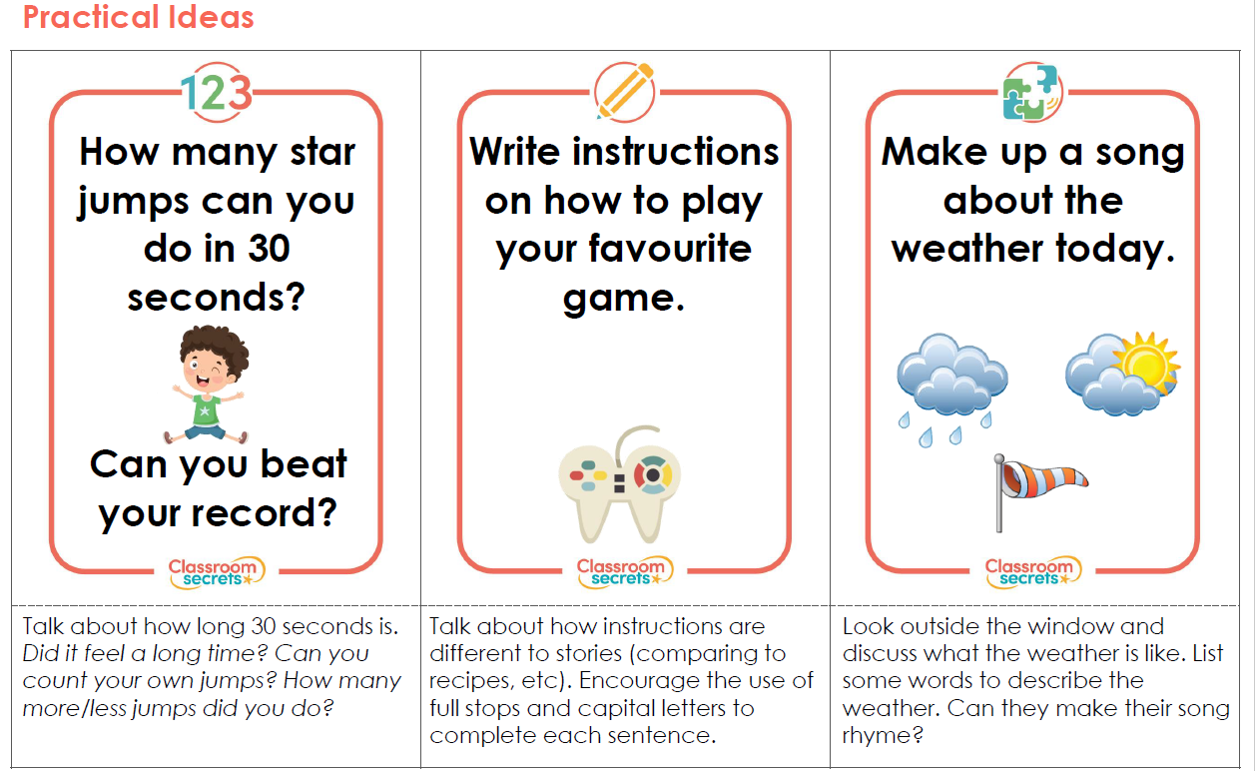
Imagination & Social Skills Ideas
Use this calendar to make a LEGO model each day.
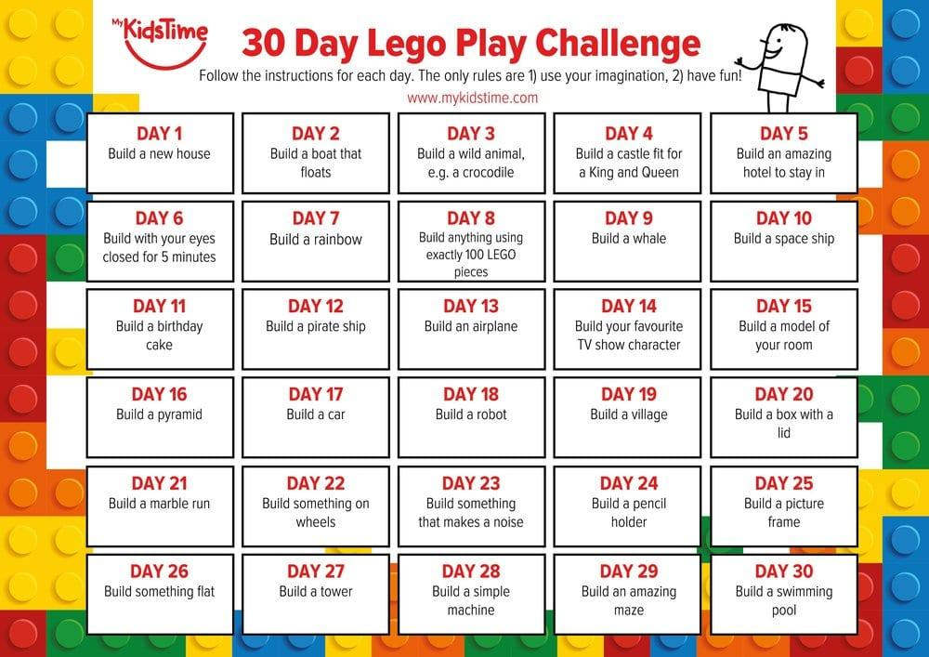
Fine Motor Skills
Use these patterns to follow with a pencil or cut out with scissors.

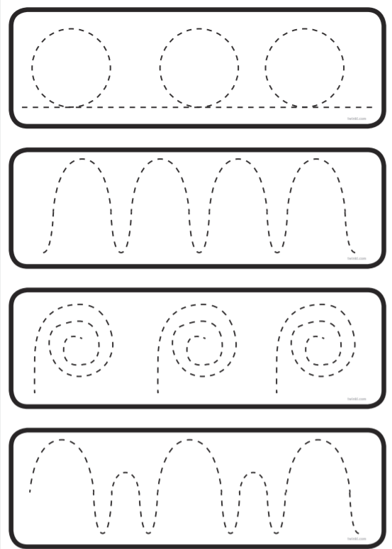

Fine Motor Skills
Use these patterns to follow with a pencil or cut out with scissors.

Fine Motor Skills
Use these patterns to follow with a pencil or cut out with scissors.
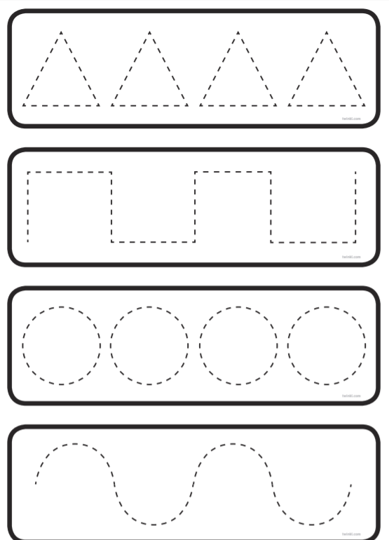

Fine Motor Skills
Use these patterns to follow with a pencil or cut out with scissors.

Maths- using language more and fewer
Once you have completed this worksheet. Have a go at home at using objects and asking your child which ones have “more” and “fewer”
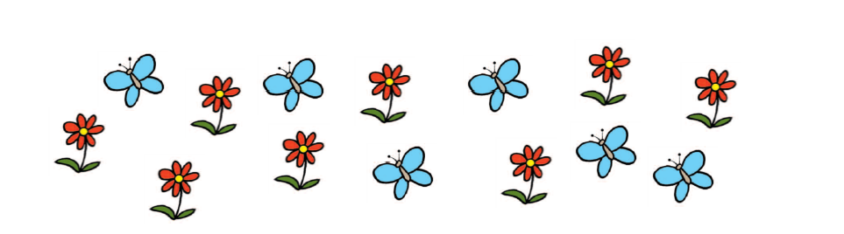
How many flowers are there?____________
How many butterflies are there?___________
Are there more or fewer flowers?__________

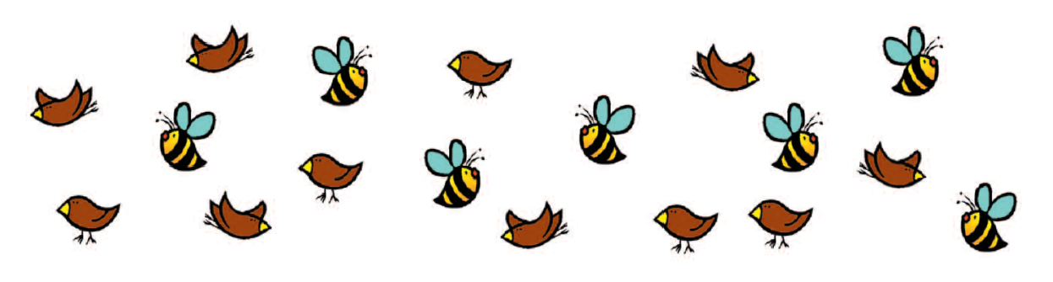
Which statements are true and false?
(Mark with a tick or cross)

There are fewer birds
There are more bees
There are 7 bees
There are 12 birds
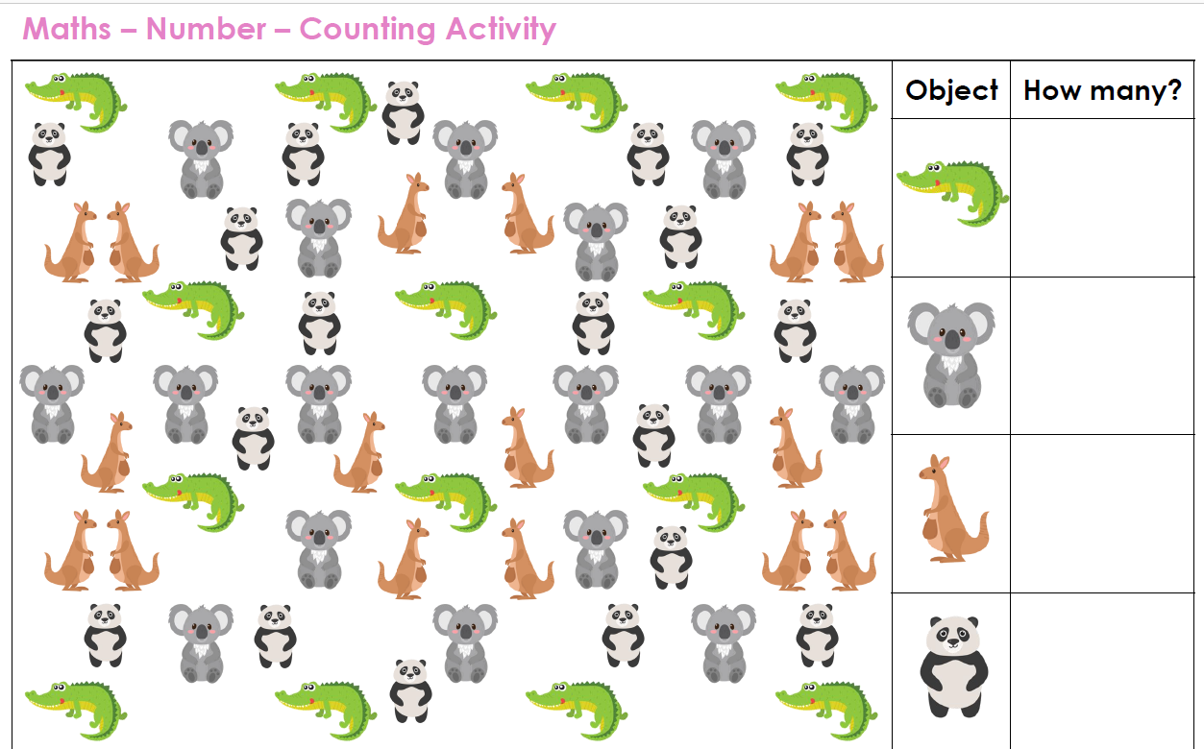
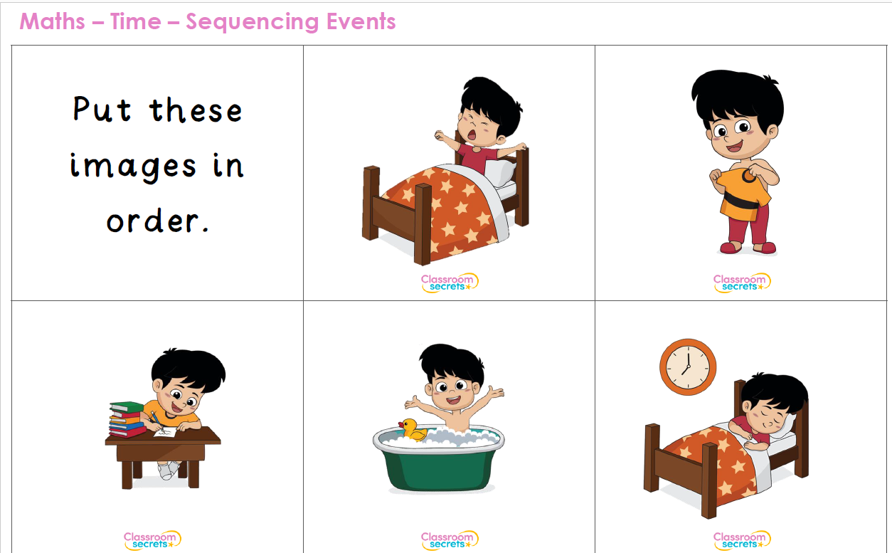
Sequencing – Use this page to sequence the pictures.
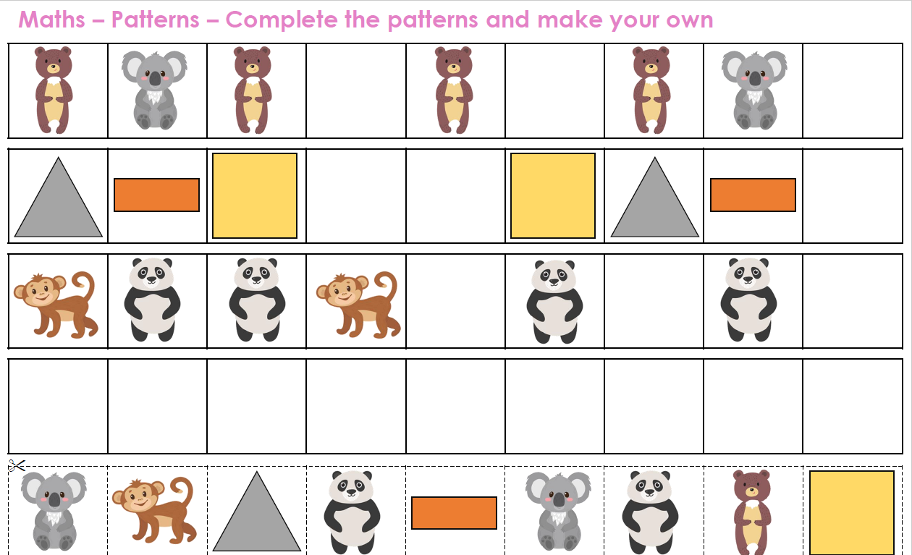
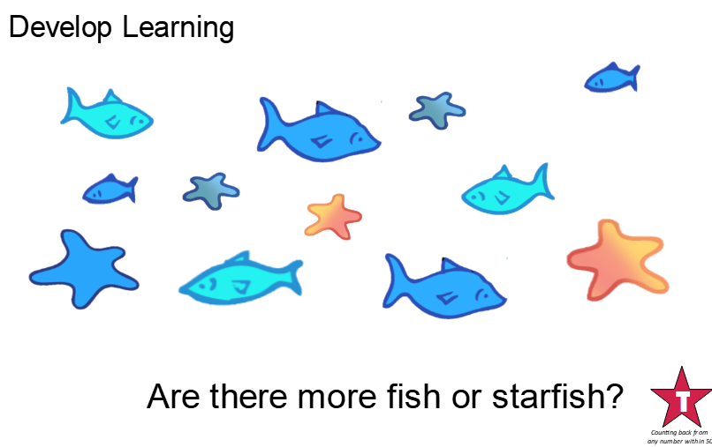

Language development

Can you use the words more and fewer to explain the amount of starfish and fish in the picture?

Can you draw your own sea life picture? Can you count the things in the picture and use the words “more” and “fewer”

My Sea Life Picture

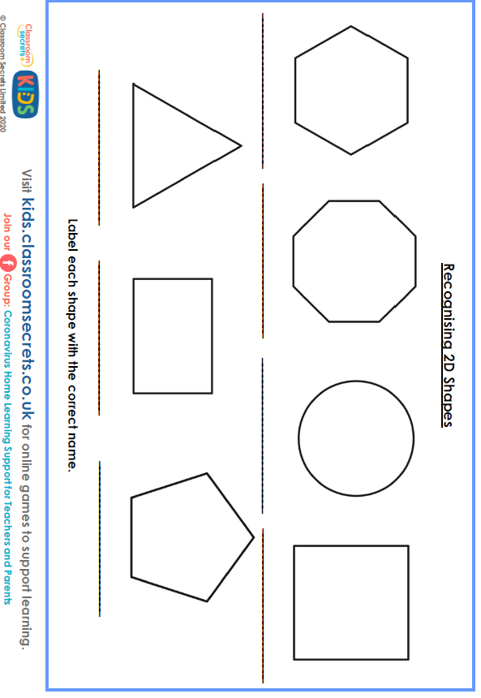
Dangers in the Kitchen

Can you circle the dangers you can spot in the kitchen?

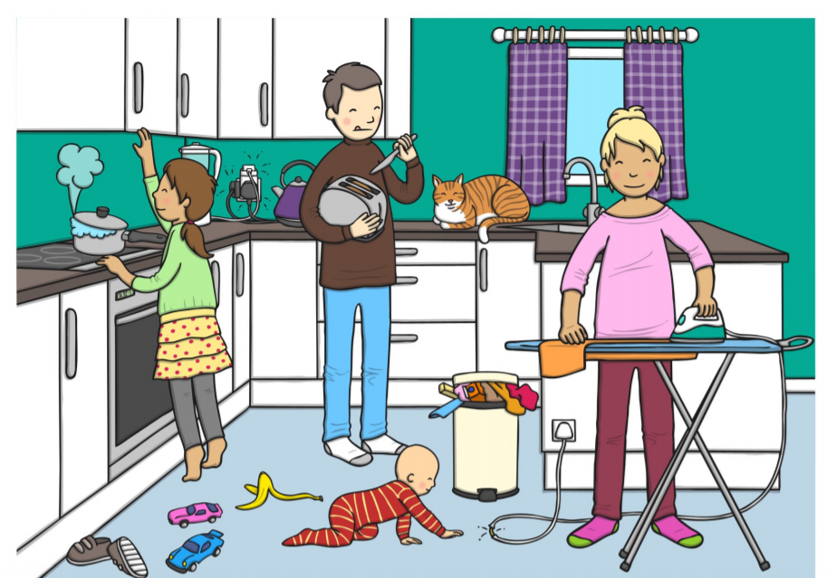
How many dangers did you find? 0000000

2) What dangers did you spot? Can you write them down?

_________________________________________________________________________________________

_________________________________________________________________________________________

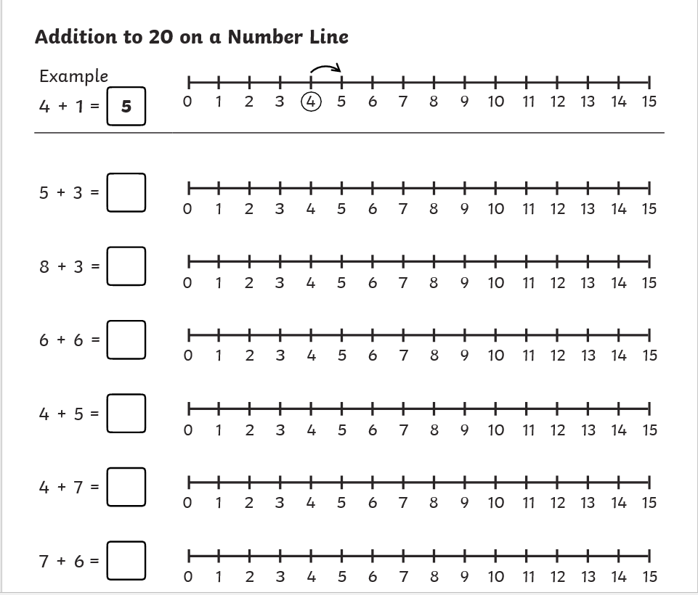

Complete these equations by using the number lines.
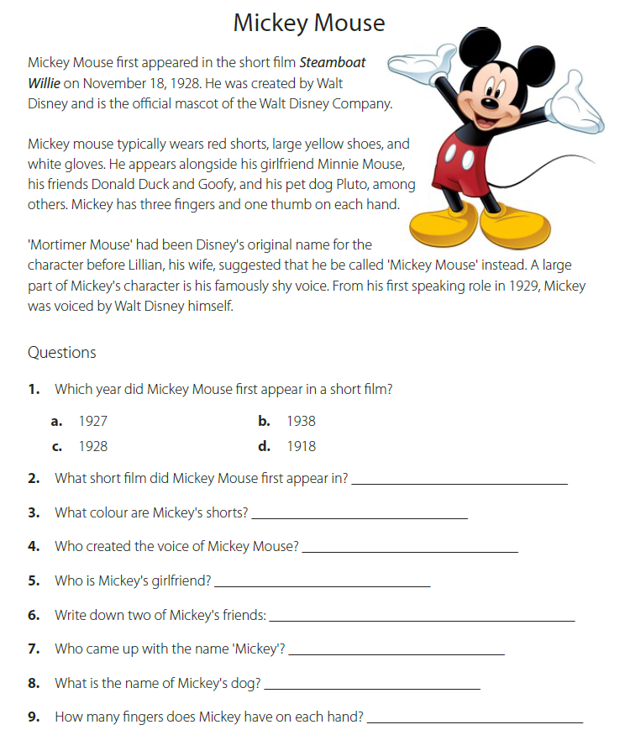
Ordering Sentences.

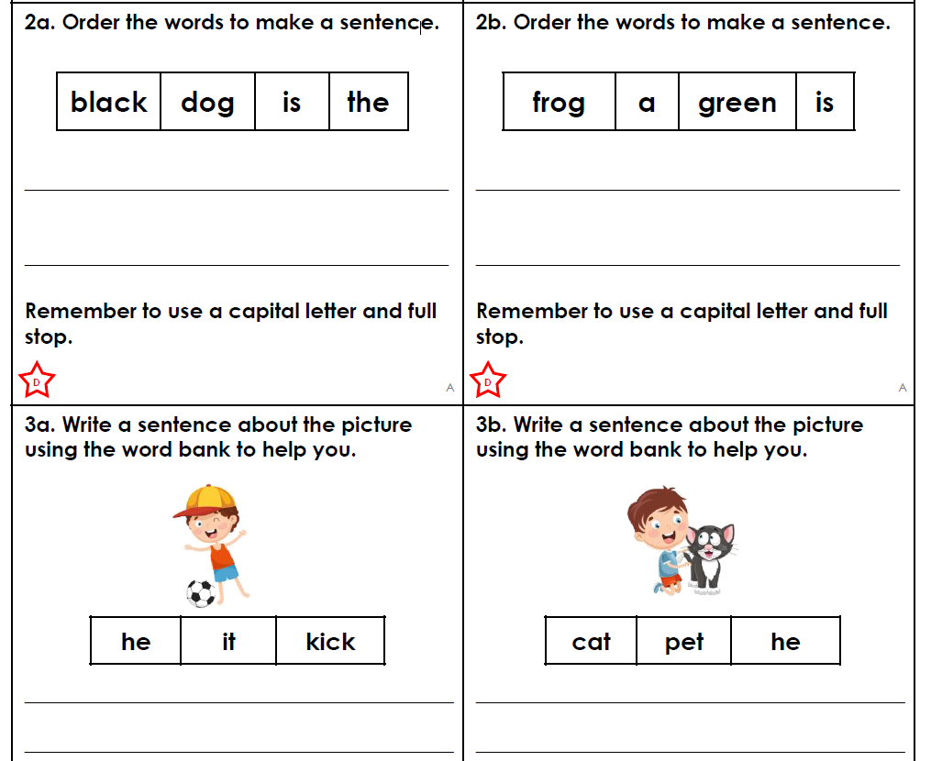

Super Hero Stories! Let’s write a story!
You can plan your story then write it by doing a little bit each day.
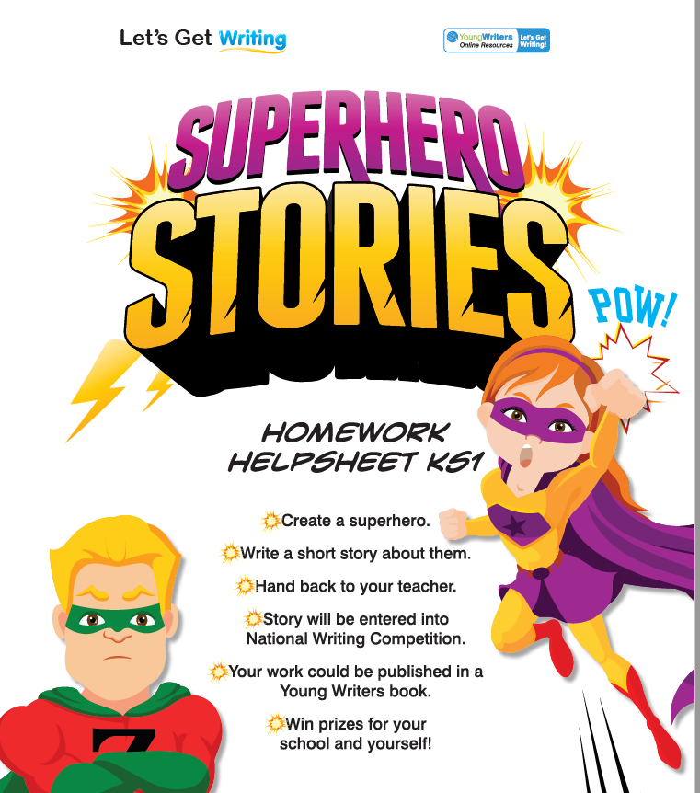
Remember capital letters and full stops.

Fingers spaces.

Check it makes sense by not rushing.

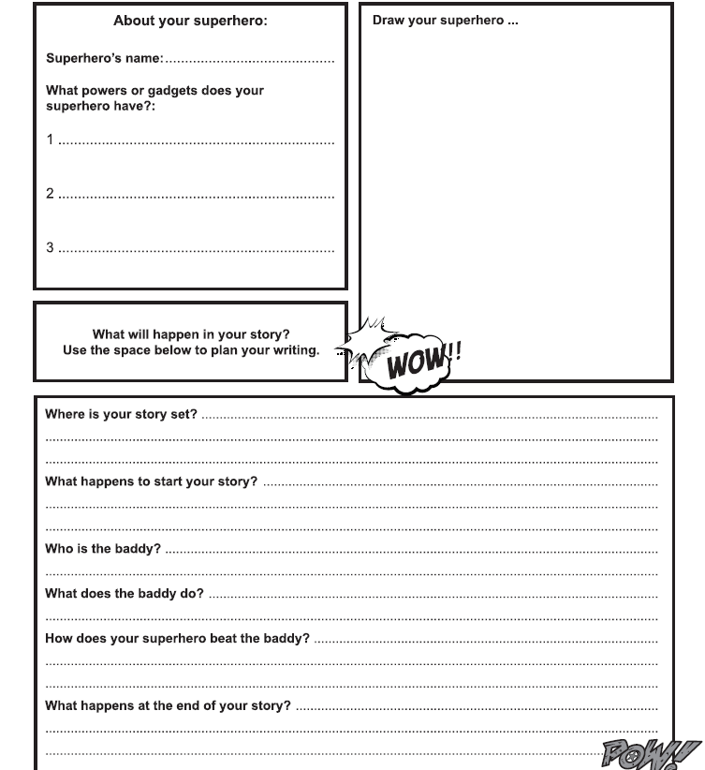
I can write a Super Hero Story!
Write your super hero story on the following pages. There is more than one page in case you need to start again or need more space.
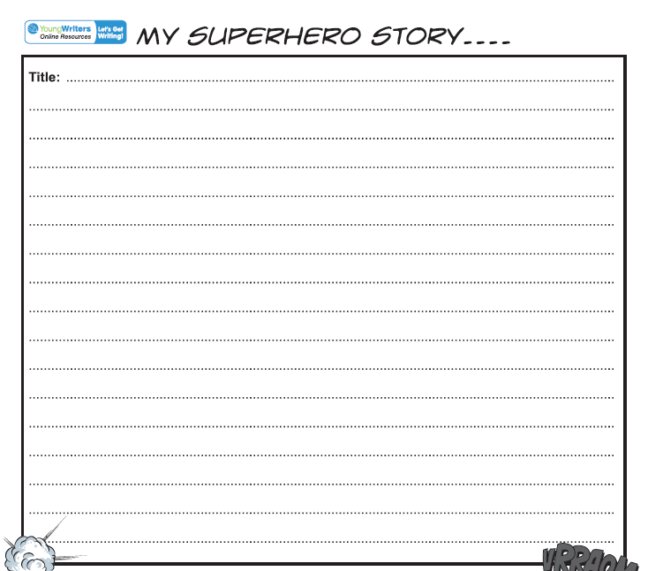
Can you edit your story by re-writing it in your best handwriting? How could you make your sentences longer with conjunctions?
Do you have any spellings to correct?
Looking at friendly and unfriendly behaviours
Sort these pictures into friendly and unfriendly behaviours. Cut the pictures out and stick them on the next page.
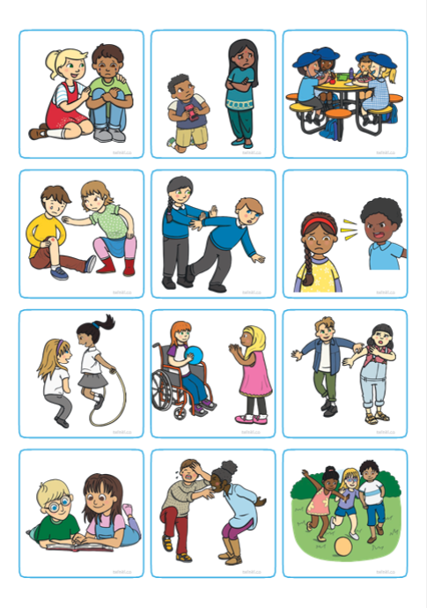
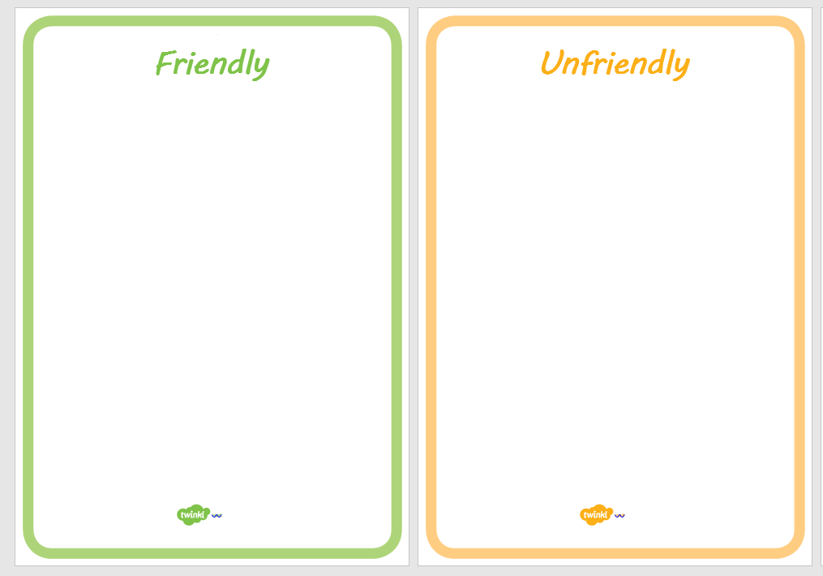
Can you draw and label a picture of your dinner.

Road Safety
I am learning how to cross a road safely
Can you cut these pictures out and order them on the next page. Number them from 1-6.

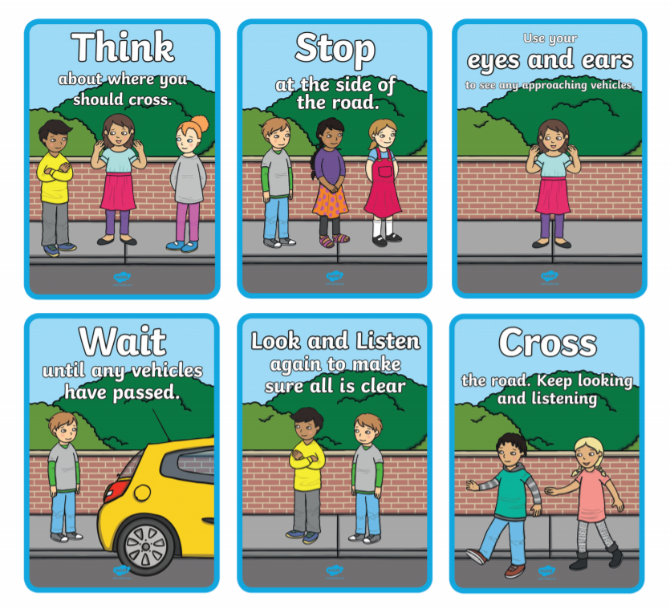

Road Safety Ordering

Can you have a go at home making numbers with tens and ones? Use the paper dienes on the next page to create numbers. The green sticks are tens, and the ones are yellow squares.
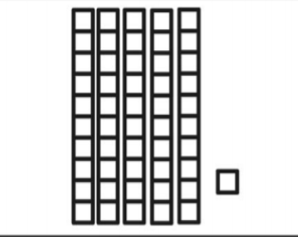 Tens and Ones Example
= 51

Challenge: can you write these numbers down? Remember it would be 51 not 501. Together you can play games such as guess the number. Parents, you can ask your child questions e.g. what would the number be if you added 5 more etc.? This activity can really challenge mental arithmetic and number understanding.
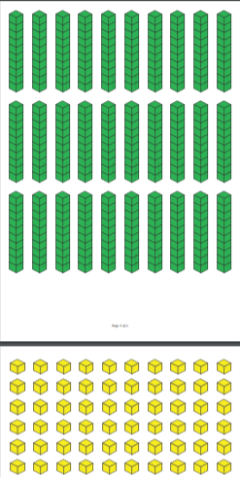

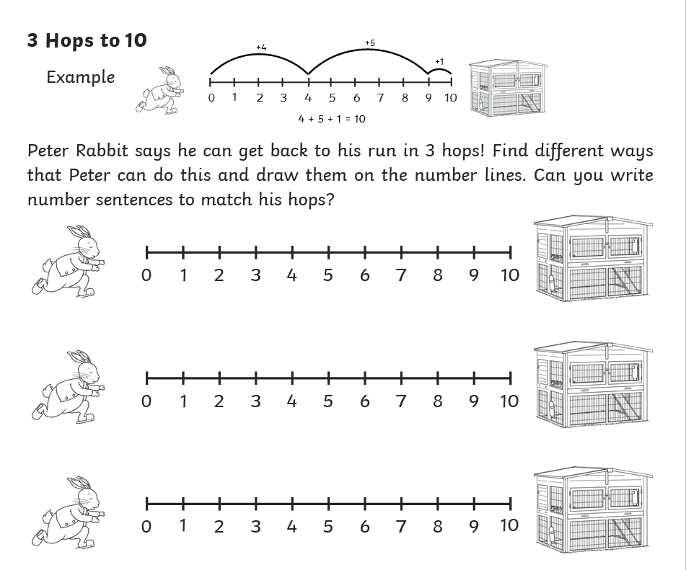

Mental Arithmetic
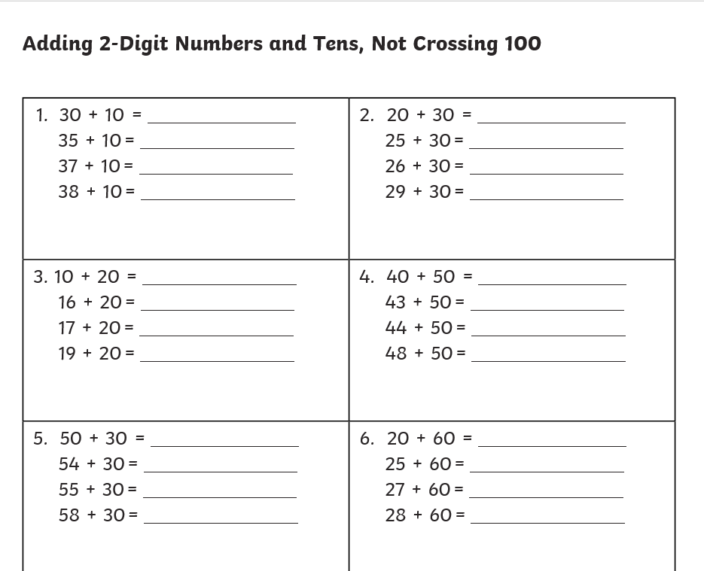

Use the numbers in the triangles to form + and – equations in the squares below. For each set of 3 numbers there are 4 equations.
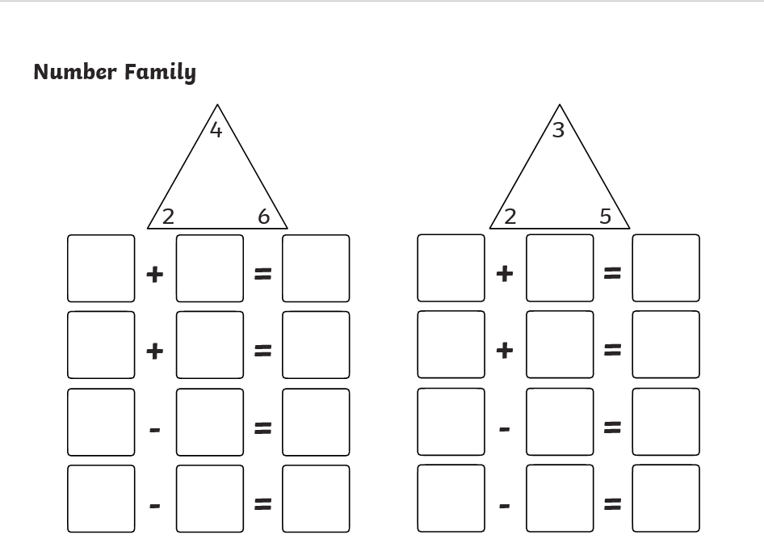
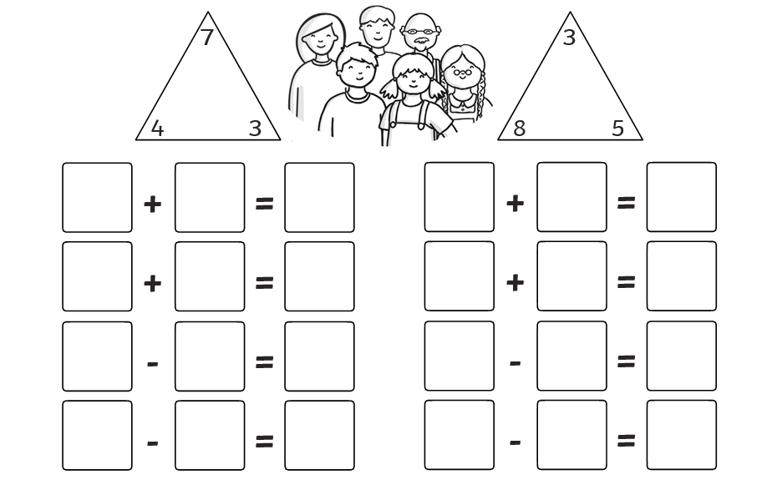
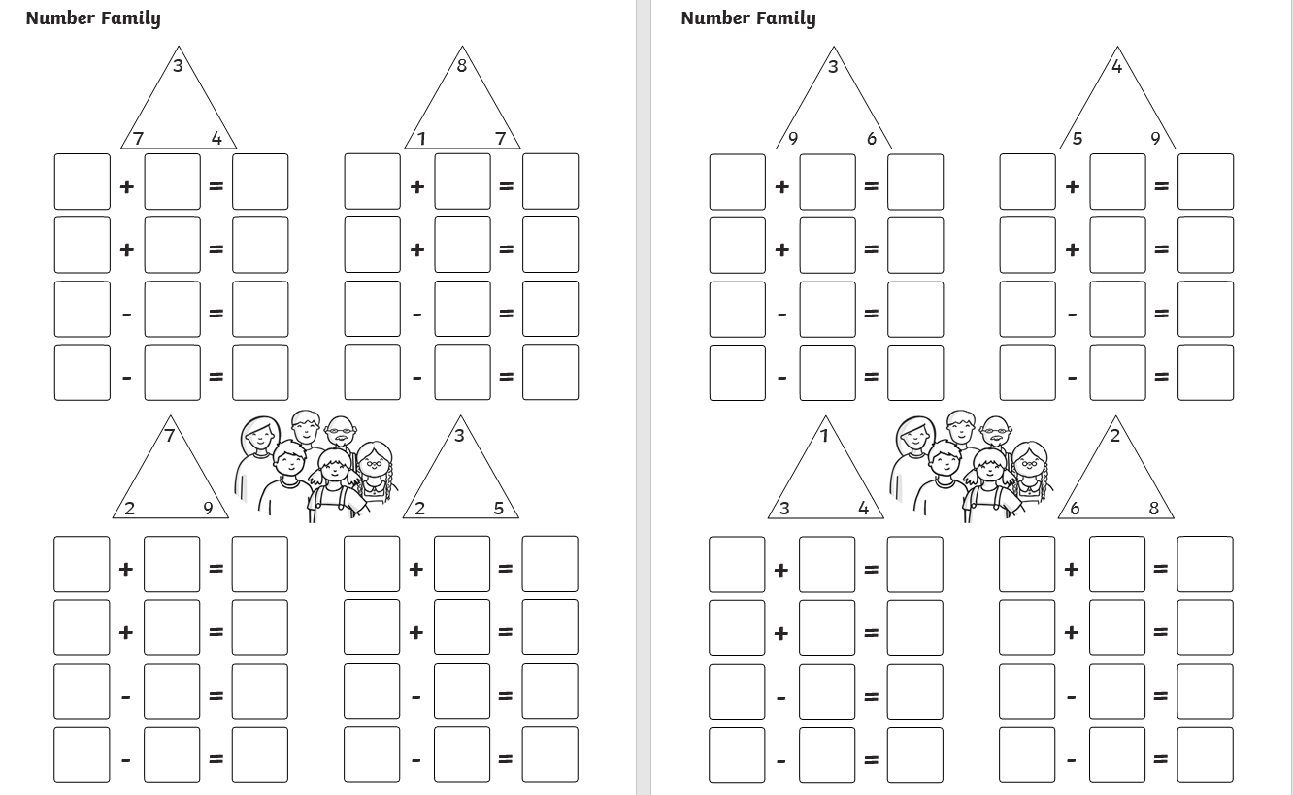

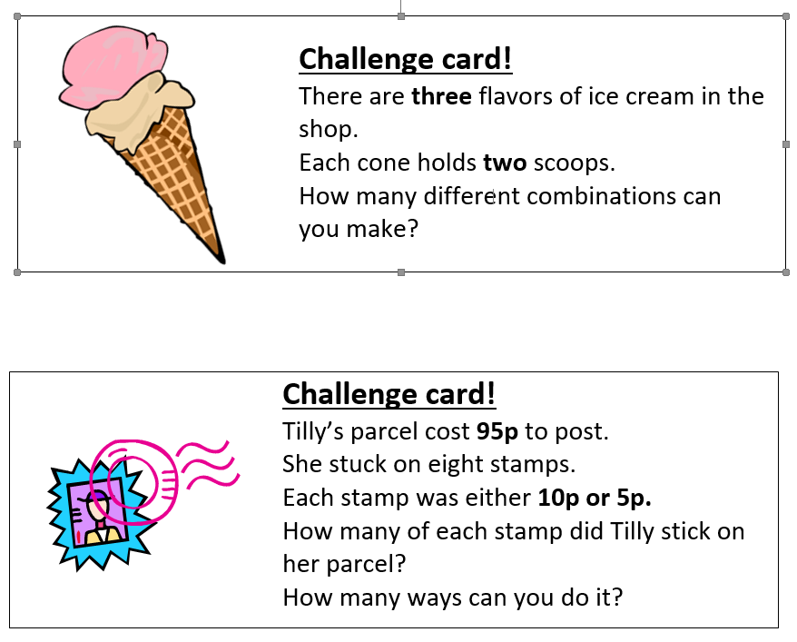
Show your answers below

Rainbow Writing
Write your name in different colours to build a rainbow.
You can practise how to write your first name and surname.

You can use this method to practise the Panda Class Words at home?

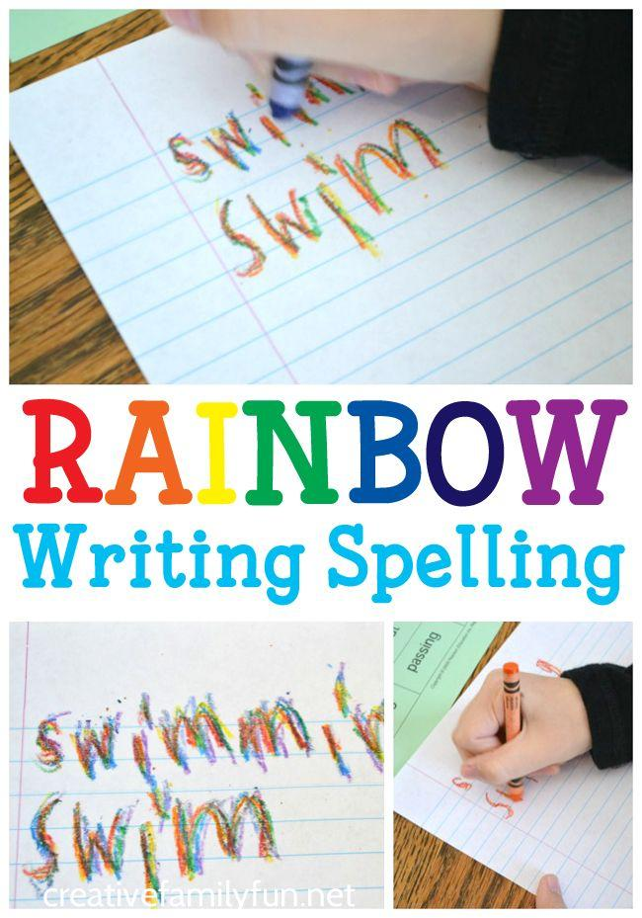

Panda Class Words

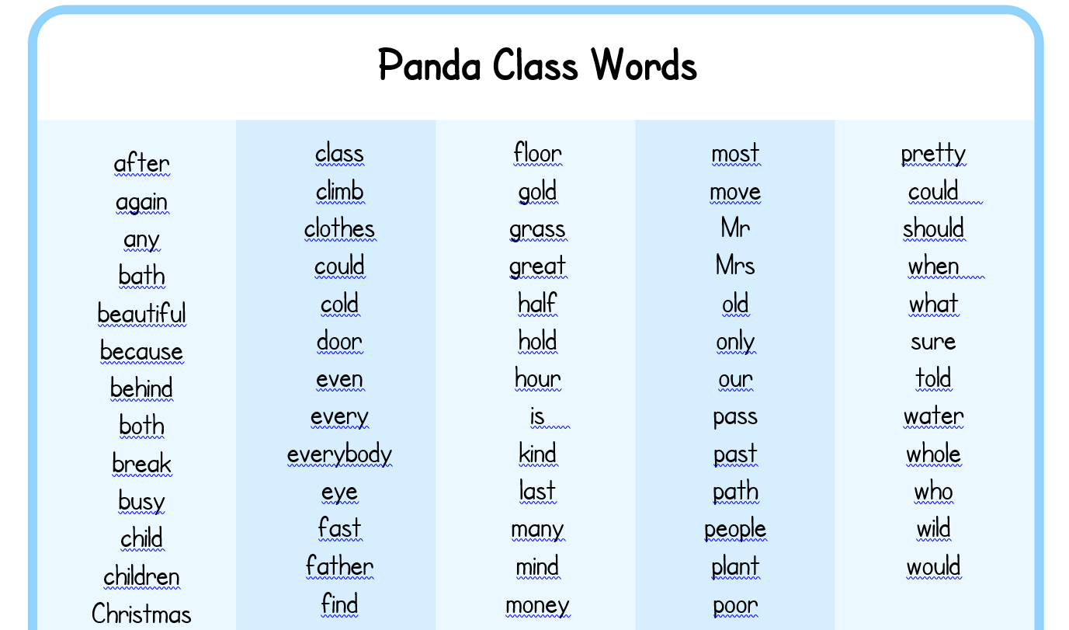
Challenge
There are larger flash card versions of some of these words below if you wanted to practise reading and writing these words.

Challenge- Can you write these words in your own sentences?
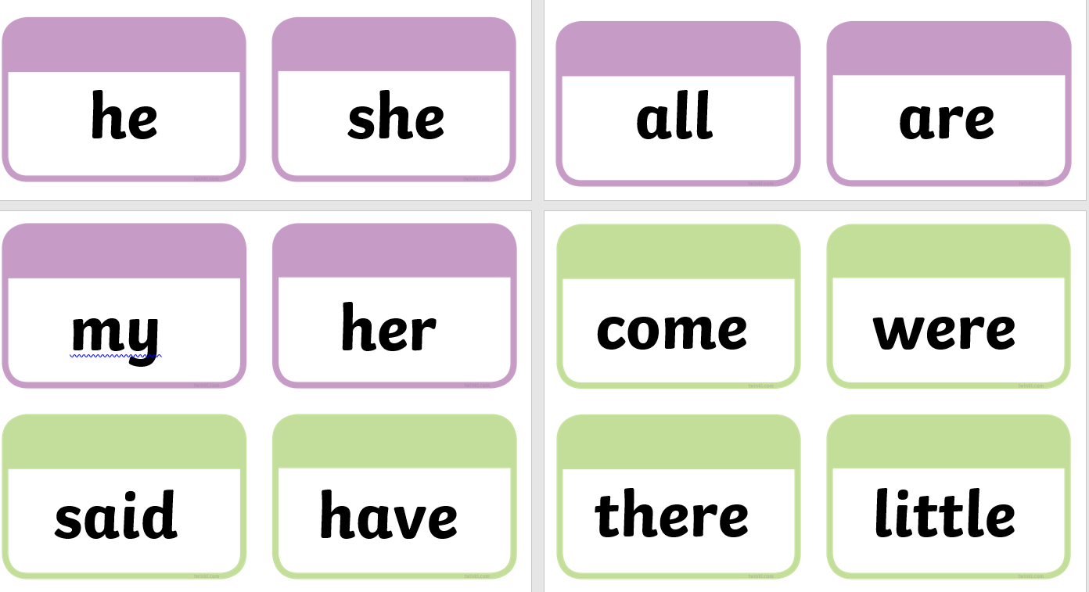
The next topic at school will be SPACE!
Complete this comprehension, the questions are on the next page.
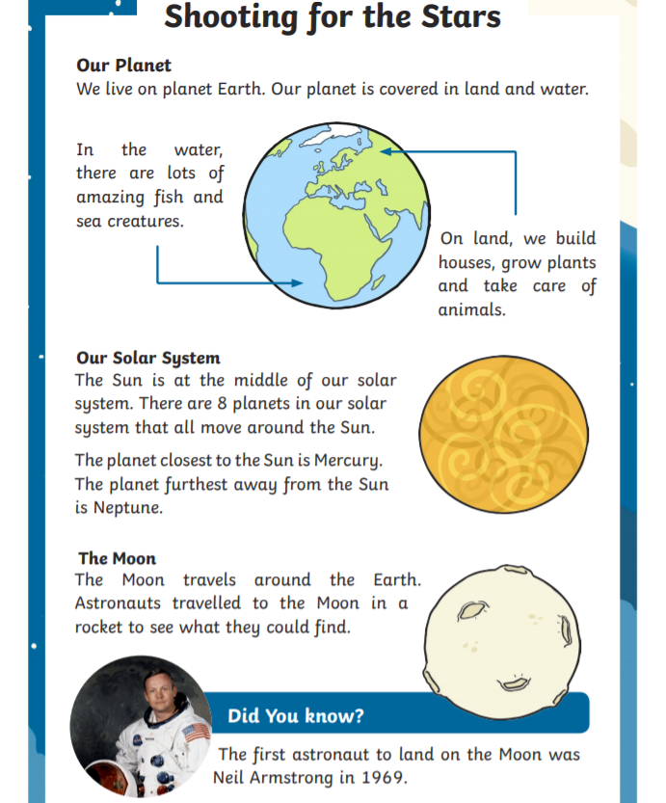
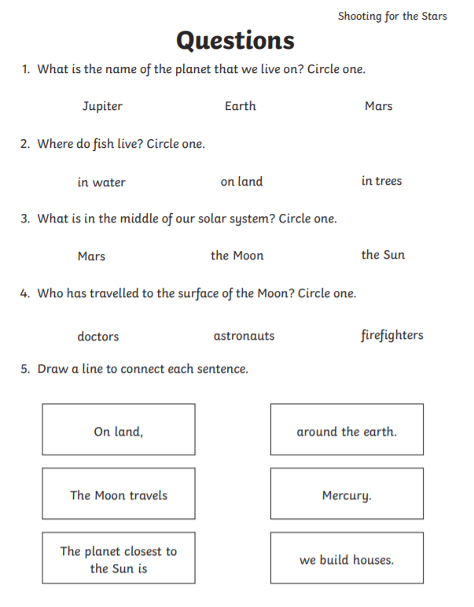
Use this page to draw a picture of your family.
Can you label your family?

Draw a picture of space.
Can you label what you have drawn?

