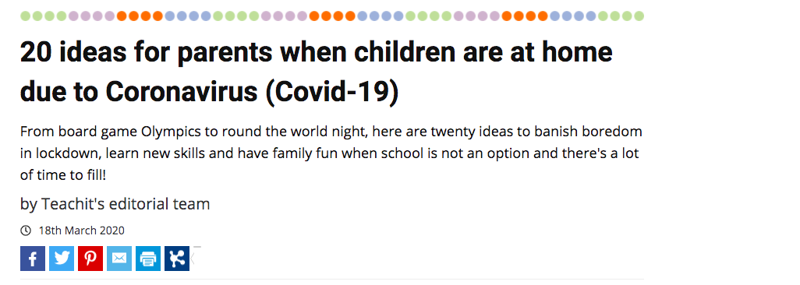

- The great outdoors. Fresh air and exercise will help to banish boredom and housebound blues. If you can, go for a walk, run or bike ride, giving your kids the map to plan the route. With younger children, give them a bag and collect ‘treasures’ on the way – a beautiful leaf, stone or flower, or go on a 'listening' walk. Nearer to home, try tree climbing in your local park or set up camp in your garden and use stargazing apps like Nightsky.

- Create a routine. Many children will benefit from a daily routine – it’s something they are used to at school. Build a plan that works for everyone and is age-appropriate. Ensure there are regular breaks and a set lunch hour and include screen-time as part of your schedule so children know what to expect.

- Reading for pleasure. Encourage your child to read daily. Set older children book reading challenges such as ‘a book a day/week’ to motivate them, or create virtual book clubs with their friends using video chat apps, Google hangouts or Group FaceTime. If you run out of books, search for free audio and ebooks online. With younger children, create book-themed treasure hunts around the house or encourage them to make their own books or draw book covers featuring their favourite characters.

- Free resources. Many educational websites (including Teachit) have free access to learning resources. Ask your child which subject/s they think they need to work on most and search online together to find worksheets and resources to suit.

- Train like a champion. Keeping physically active is particularly important for children. Research the training regime of a famous sportsperson or idol and get your child to create their own daily or weekly training programme, using videos and apps to help. Keep a record to track their progress and use rewards to motivate them, or set them the challenge of creating a family workout with DIY circuits and time trial challenges. Younger children might enjoy Go Noodle or Cosmic kids yoga for their daily workouts.

- Learn a lingo. While foreign travel may not be possible, virtual language lessons are. You can find a rich selection of videos and free apps to help your child learn some of the basics of any language in the world. Set them a challenge – how many languages can they count to ten in by the end of the week? How do you say hello in Japanese?

- Good neighbours. Think of ways your family could help neighbours or older people in your community. Could your children write letters to residents of local care homes, create little gift boxes, bake some biscuits or simply pick a bunch of flowers from your garden to brighten someone’s spirits?

- Be more Greta! Take this opportunity to get back to nature as a family. Plant a few veg seeds or a bee-friendly wildflower patch. Try your hand at making seed bombs, a bug hotel or a birdbath and feeder. Trees for schools and the RSPB have lots of child-friendly ideas, upcycling projects and resources online.

- Family jobs. Even very young children can be encouraged to help more with jobs around the house. Older children might enjoy projects such as room makeovers and DIY, mowing the lawn or cooking family meals. Younger children might like to get involved in looking after pets, cleaning the car, sweeping up or using the vacuum cleaner.

- Making movies. Encourage your children to make stop motion shorts and Lego-style movies with apps like Stop Motion Studio, or use Telestory to make themed tv shows with backgrounds, costumes and special effects, or create cartoons with Toontastic. They might also like to experiment with green screen apps.

- Time travelling. Keep a daily diary for future historians studying the Coronavirus pandemic or create and bury a time capsule for future generations to find.

- Pinspiration. Pinterest is a great source of ideas and step-by-step photo guides. Search for craft tutorials, fitness workouts, ideas for rainy days, tips for room makeovers and incredible recipes. If your child has a special interest, you’ll find something to excite them.

- Photodiary. Get your children to make a photodiary, collage or scrapbook for something they are learning about, cutting and sticking images or using a tool like Bookcreator to make their own digital book. Older children could use this for school work or revision.

- A night at the movies. Dim the lights, get your favourite snacks or popcorn and settle down for a family night in with a favourite film. Work your way through the classics, or let a different family member choose each night’s entertainment.

- Friends in need. Help your children feel connected to others. Younger children might enjoy exchanging digital messages with friends in secret code or swapping drawings online. Older children can sign up for an international pen pal online or join Post Crossing to send and receive postcards from around the world, while teenagers will enjoy virtually hanging out with friends using Zoom or the Houseparty app.

- Board game Olympics. A great way for siblings to play together at home, set up a board game competition based on the Olympics including all your favourite family games. Compete for medals in each ‘category’ and keep a medal tally.

- Learn a new skill. Encourage your child to try something they have always wanted to do – learn to touch type, bake a cake without adult help, use Morse code, make a fire or master football tricks etc. Challenge them to perfect their skill over a week by practising regularly.

- Round the world night. Take it in turns to cook a meal or order a takeaway from a different country. Make it more authentic by listening to music and watching films, cooking or travel programmes or even cartoons from that country – search YouTube or Spotify for playlists.

- Virtual museum trips. While many museums have restricted opening times, you can still visit their collections online. The Science Museum, British Museum, Museum of London and Natural History Museum all have resources for children, and NASA has a range of space projects for kids. You can even do a virtual tour of over 500 international museums using Google Arts and Culture.

- Wonders of the world. Extend children’s natural curiosity about the world with specially selected Ted talks, or use Common Sense Media for suggestions for children’s documentaries and podcasts, along with reviews and age ratings. The Week Junior and the BBC’s Newsround will help to keep kids up-to-date, along with a weekly online news quiz.

